Particulate Flow Rate Determination on Wetscrubber
Titles should be based on the highlight or subject of paper. Avoid report-like titles. Concise, accurate, and specific. Titles should describe content. Avoid abbreviations where possible.

Author’s Name¹, Author’s Name² and Author’s Name³
¹Balai Besar Teknologi Pencegahan Pencemaran Industri
²Balai Besar Kulit Karet dan Plastik
³Balai Besar Batik
Email : emailpenulis1@kti.com
Please write the given name and last name of each author without abbreviations. Write author’s affiliation and the address of correspondence author

Abstract

Abstract should embrace and describe your paper. I t should contain 200 – 300 words. Provide a minimum of three keywords. The abstract should describe : brief background, method, result, and conclusion. It must be able to stand alone (do not refer to figure / table / reference). Uncommon abbreviations should be avoided. Use concise, clear, specific, and accurate words.

Keywords : keyword1; keyword2; keyword3
Use semicolon (;)

INTRODUCTION
The most important part of introduction is the state of the art of previous studies (literature overview or concept of theories); describe the gap analysis. State the objectives of the work. Hypothesis may be stated in gap analysis. Provide general background in one paragraph. State of the art should be based on minimum of 5 references to justify novelty of the work (generally about 2-3 paragraphs). Describe the findings of each references instead of describing the references separately (Two or more references may contain the same findings).

METHODS
Methods should contain material and equipment (include the specifications if possible) and procedure. Methods should be written in passive, concise, clear, DETAILED and COMPLETE. Provide details to allow the work to be reproduced by another researcher (reproducible). State chemicals (only precursor) in methods; the mixed solution should be stated in procedure (example : Ca(NO₃).xH₂O (99%,Merck)). Common and general methods should be referred to the original reference (book). Mention only the main instrumentation used in the work.

RESULT AND DISCUSSION
RESULT should contain findings instead of detailed result. Do not describe detailed numbers (table or graphic); state the finding or trend. Present data contribute to discussion. Do not hide any result, since it may contain novelty of the work. Consistency: Please ensure that figures/tables cited in text (and vice versa).
Result and discussion should be supported by figures and tables according to following format:
Table 1. Flowrate as a function of time
No | Condition | Flowrate (m/second)
1 | Unloaded | 15
2 | Loaded | 12

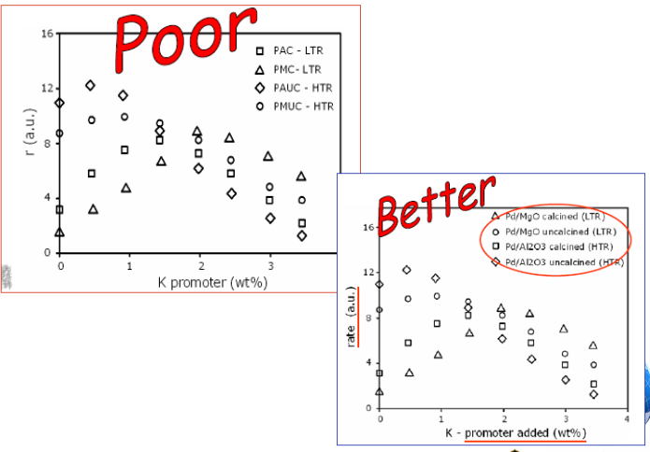
Figure 1. Water consumed as a function of elapsed time

Citation in the text should be provided with name and year in parentheses. Reference list should follow standard reference style of JRTPPI (see website). Example:
- This material has been applied extensively (Zen et al.,2009)
- This result was contradicted with Becker and Seligman (Harihastuti, 2007)
- This effect has been commonly studied (Subandrio, 2004; Marlena et al., 2010; Hanny, 2011).
- This effect has been commonly studied (Marlena and Harihastuti, 2011).

Discussion should be explored with findings statement (avoid redundancy). This should contain at least :
- (What/How) Processed data should be presented in table or figure. Annotations should be clear, explicit, and unambiguous.
- (Why) Should express result and related to basic concept and/or hypotheses.
- (What else) State any conformity or contradictory to other studies.
- It is advised to describe the implication of result, in respect of theory and application.

CONCLUSION
This should be described in concise and clear sentences. It should address and answer hypotheses based on original and solid data. Avoid repetition of abstract or result.

ACKNOWLEDGMENT
REFERENCE
JRTPPI has its own reference template available in website. This include product that support Citation Style Language styles, Mendeley . Using Mendeley Desktop, authors only need to select journal template when preparing their article, after which citations and bibliographies will be automatically formatted in the journal's style.
Articles using Mendeley Desktop will be prioritized.
------------------------ see next page for JTPPI Citation Style Utilization -----------

Step to use JRTPPI Citation Style :
- Open Mendeley Desktop, point to View-Citation Style-More Styles
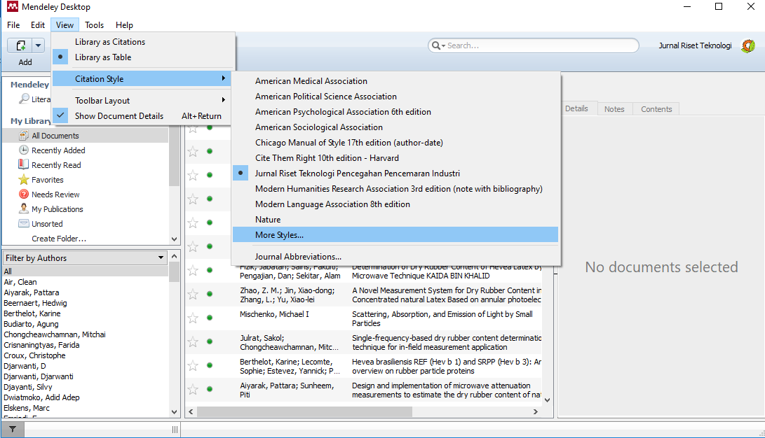
- On Citation Style tab window, access to Get More Styles, copy paste this link to Download Style tab;
https://www.dropbox.com/s/i07cf24mhlyyq0s/jurnal-riset-teknologi-pencegahan-pencemaran-industri.csl?dl=1
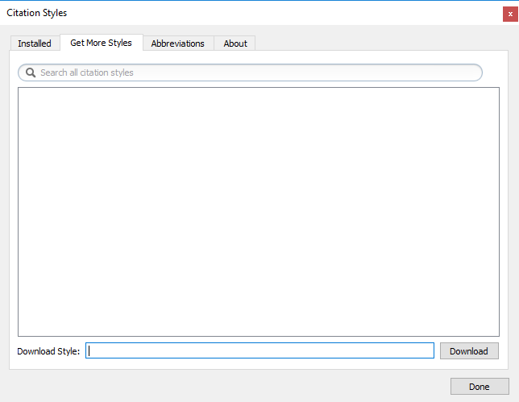
paste here
- Click download, another window will appear; click Use this Style
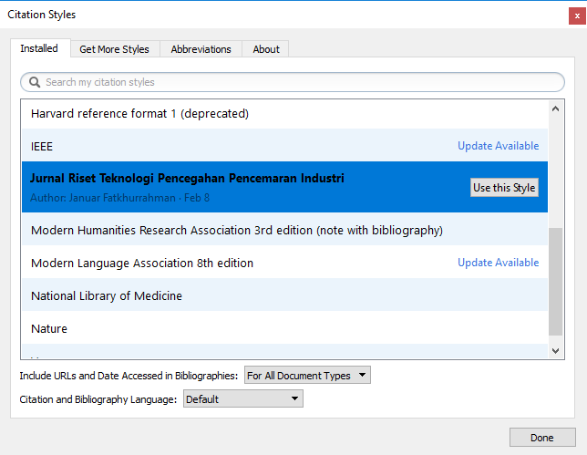
- Switch to Microsoft Word where you left your paper for reference and bibliography editing. Point to Reference tab, choose JRTPPI citation style.
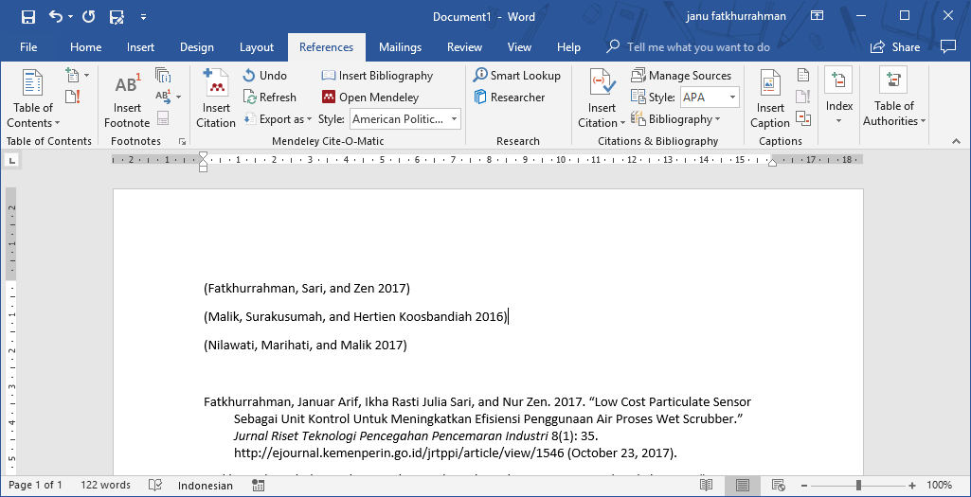

- Voilaaa... your paper automatically switched to JRTPPI citation Style
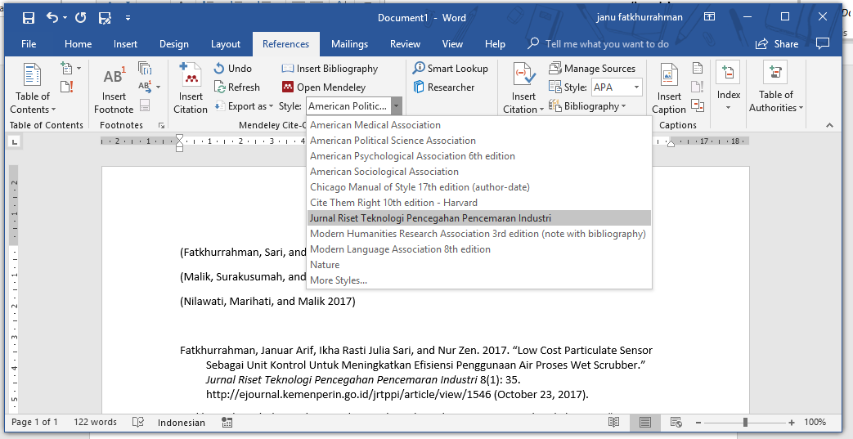
- Feel free to ask JRTPPI contact person for help.

